Ideias Pensadas

AFONSO

* AITECH Solucoes Digitais (afonso)
* GoalKeeper finder app (Bruno)
* Baby monitor AI Assitante (afonso)
  + “Help parentes to relax a bit more”
* TicketShop – blockchain technology anti fraud to sell tickets using ladger
* Motion Tech – desenvolvimento de pesquisa em motion Technologies (Virtual reality, METAVERSE, robotization, robotics,
* AUTOPARTS intell: AI assistante trainned under automotive industry to support repair shops to learn and search how to install parts, specifications, applications, etc

DATA SCIENCE IDEAS -AITECH

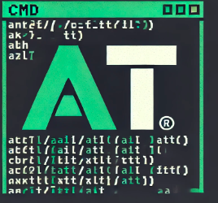 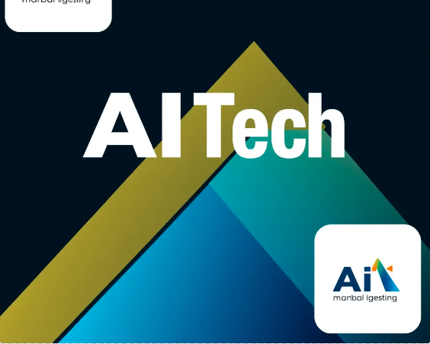 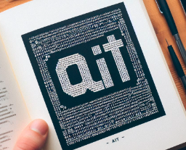 

Data science is a multidisciplinary field that analyzes data to extract insights for business. It combines techniques from many fields, including: mathematics, statistics, computer science, artificial intelligence, domain knowledge, and data engineering.

Data science can be used to: Optimize business processes, Discover new insights, and Create new products and solutions.

Data science projects typically go through a lifecycle that includes: Data collection, Data cleansing, Analysis, Modeling, and Communicating results and insights.

Data scientists use a variety of tools, including: Programming languages like Python and R, Big data frameworks like Hadoop and Spark, and Machine learning algorithms.

Data science is a key part of innovation and strategic decision-making across many industries. The global data science platform industry is expected to reach a peak of around $133.7 billion, and demand for data scientists is set to grow.

People’s relationship with technology is at a critical juncture. It feels like something that happens to them rather than for them, demanding too much and often failing to make a positive impact on wellbeing. Businesses can’t shy away from the frustration and fatigue, so their best route is to become part of a solution that boosts people’s sense of agency.

41%

of frequent tech users say that technology has complicated their lives just as much as it has simplified it.

#### 37%

say it’s more important than ever to apply critical thinking regarding what technology they use and how.

Organizations must be thoughtful about how their use of technology will fit in to people’s lives and what it will demand of them. Time? New skills? Brands that offer people greater choice in how they use (or don’t use) technology to interact will become trusted partners, because customers will be able to regain a much-needed sense of agency.

[*https://www.accenture.com/us-en/insights/song/accenture-life-trends*](https://www.accenture.com/us-en/insights/song/accenture-life-trends)

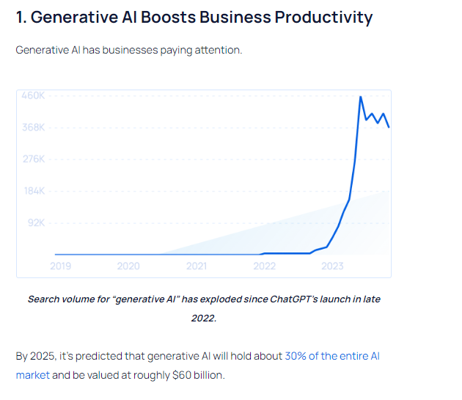

(The generative AI space [is currently worth approximately $45 billion](https://explodingtopics.com/blog/generative-ai-stats))

Consumers are expecting businesses to capitalize on generative AI applications — [nearly 70% of consumers](https://www.zendesk.com/blog/generative-ai/) say they believe most businesses will soon be using this technology to improve the customer experience.

Generative AI platforms run on the technology of [large language models](https://www.boost.ai/blog/llms-large-language-models) (LLMs).

LLMs are trained on billions of pages of existing text. As they are trained, LLMs pay attention to contextual relationships between the words and patterns seen in sentences. From there, the LLM can generate content on its own.

For example, the [BERT](https://www.techtarget.com/searchenterpriseai/definition/BERT-language-model) LLM can achieve [85%-90% accuracy](https://www.forbes.com/sites/garydrenik/2023/01/11/large-language-models-will-define-artificial-intelligence/?sh=2417a49fb60f) in just milliseconds.

And LLMs are only getting better.

In the future, AI experts say these models will be able to generate their own training data to self-improve, pull in information from external sources, and operate much more efficiently through an approach called “sparse expert models.”

Boston Consulting Group reports that some expect that generative AI will be able to put out [“final draft” content by 2030](https://www.bcg.com/publications/2023/ceo-guide-to-ai-revolution).

As of now, LLMs are far from perfect, but businesses are already taking advantage of their [wide-ranging capabilities](https://www.mckinsey.com/capabilities/quantumblack/our-insights/generative-ai-is-here-how-tools-like-chatgpt-could-change-your-business).

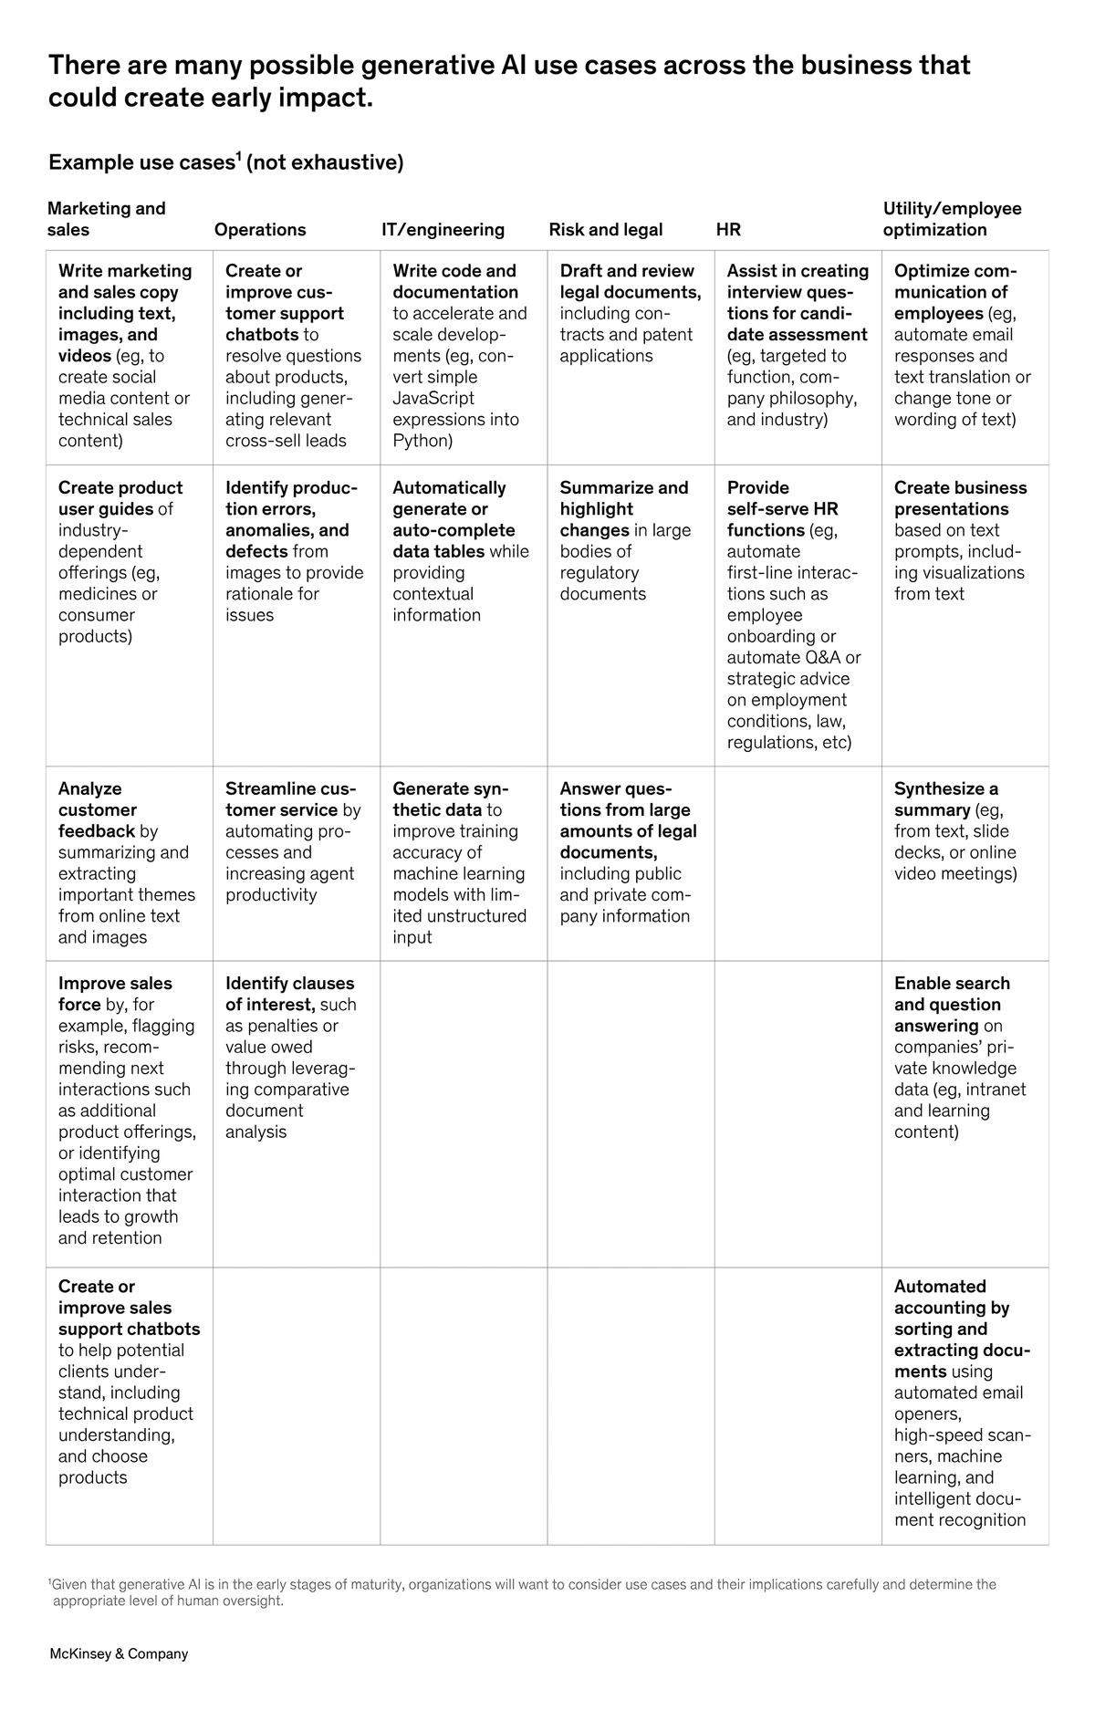

**In 2023, customers have more purchasing options than ever. That means businesses must work even harder (and smarter) to attract and retain customers.**

**70% of organizations say customer service is directly connected to the performance of their business and 63% of them are prioritizing the customer experience.**

**One critical way businesses are improving customer service is through the use of artificial intelligence (AI) solutions.**

**Gartner reports that customer service budgets are directing increased spend to tech solutions.**

**Technology is seeing a 7.6% boost in spending while increases in training and development and personnel are seeing only modest increases hovering around 3%.**

**https://explodingtopics.com/blog/business-trends**

**Produto digital oferecido as SaaS (System as a Service) especializado em implementação de AI generativa , Machine Learning, Process automation and nos processos organizacionais /sociais** e desenvolvimento de produtos digitais com foco em gerar valor ao cliente final. Produtos ofertados:

-> Baseado em APIs oriundas das mais recentes LLMs (*Large Language Models)*  e em GLMs (Generative Language Models) assim como to provide agility, cost reduction, process automations and competitiviness e desenvolvimento de produtos digitai

-> Machine learning implementation for business process

-> AI agents for customer services , finance, planning, manufacturing control, purchase, sales, logistics, governance, quality control and project management skills

-> Easy to manipulate model, clear interface, user input directions and tasks,

Customer Segmentation

* Freemium (no fee / free for personal usage /
* On demand
* Business Account
* Premium accounts

Missao valor e visao

**MISSAO**:

Reduzir os desperdícios e ineficiências dos processos organizacionais ,pessoais e sociais através da elaboração de uma plataforma de venda de agentes virtuais que executam escopo de atividades semelhantes baseado em machine leraning, Large language models e Genenative Language Models

**VISÂO:**

**Em 10 anos , a AITech Soluções e Produtos Digitais será líder no segmento de venda e intermediação de agentes de inteligência artificial, fornecendo soluções orientadas e eficiência organizacional e ciência de dados.**

**VALORES**:

* - Transparencia
* - Integridade
* - Agilidade
* - Qualidade e Melhoria Continua
* - Eficiencia
* - Racianalidade
* - Orientado a Valor e Clientes
* - Privacidade e Seguranca de dados

Analise do mercado selecionado e perfil dos clientes